

Specification

for

SQLdm Desktop Client (Project Houston)

Trent Miskelly

11/17/06



Proprietary and Confidential to BBS Technologies, Inc.

© 2006 BBS Technologies, Inc.; all rights reserved.

Revision history:
When? | Who? | What?
10/20/06 | Trent Miskelly | First draft – 50% coverage
10/27/06 | Trent Miskelly | 75% Coverage  Added Quick Start Wizard.  Completed Alerts feature, including notification rules.  Completed Tasks feature.  Completed high-level Reports feature.  Completed Session views.  Completed Log views.
10/29/06 | Trent Miskelly | 90% Coverage  Completed Query Monitor views.  Completed Resources views.  Completed Services views.
10/30/06 | Trent Miskelly | First Draft Complete  Completed Databases views.
11/19/06 | Trent Miskelly | Final Draft

Table of Contents
1. Revision history: ii
2. Table of Contents iii
3. Requirements 1
3.1. Overview/Purpose 1
3.2. Target Users 1
3.3. Features 2
3.3.1. Required Features 2
3.3.2. Non-Supported Features 3
3.4. FAQ 3
3.5. Open Issues 3
4. Functional Design 3
4.1. User Interfaces 3
4.1.1. General User Interface Considerations 4
4.1.2. Splash Dialog 5
4.1.3. Connect to SQLdm Database 5
4.1.4. Import Wizard 5
4.1.5. Main Form 6
4.1.6. Getting Started 12
4.1.7. Server Explorer 12
4.1.8. Alerts 50
4.1.9. Tasks 53
4.1.10. Reports 55
4.1.11. Misc Dialogs 56
4.1.12. System Diagnostics 70
4.1.13. Help Integration 70
4.2. Installation and Upgrade 71
4.3. Permissions and other Required Configuration 71
4.4. Licensing Issues 71
4.5. Dependencies 71
4.5.1. Dependencies on Idera Software 71
4.5.2. Third-Party Software Required on the Customer Machine 71
4.5.3. Third-Party Software Required Internally 71
5. Technical Design 71
5.1. Architecture 71
5.2. Installation Issues 71
5.3. Schedule 72
5.3.1. Work Breakdown and Sizings 72
5.3.2. Areas of Risk 72
6. Quality Assurance Considerations 72
6.1.1. Overview 72
7. Documentation Considerations 73
8. Bibliography 73

Requirements

Overview/Purpose
The SQL diagnostic manager desktop client is being updated and written from scratch in C# for several reasons:
- We’re making a big move to transform SQLdm into an integrated diagnostic environment. To realize that vision, much of the organization of SQLdm must change, so that it’s no longer a group of disparate monitoring tools. This goal opens up the opportunity to also address additional maintenance issues mentioned below.
- The existing desktop client is written in Visual Basic 6 (a dated and dieing programming language) and has been modified by many disparate teams with little or no documentation, causing an expensive and unnecessary cost to maintain.
- Due to the nature of the new SQLdm distributed architecture, all real-time monitoring would have to be removed from the existing desktop client, resulting in very high-risk changes to an already unwieldy code base.
- Idera is modernizing the look-and-feel of our major products, using the navigation paradigm pioneered by Microsoft Outlook 2003. This would be a major change to the existing code base and would require a significant number of custom UI components to be written that are already available in modern .Net libraries.
- Many of the existing views have usability problems about which customers have complained. Simply updating the UI components with more modern components available in .Net would fix many of these problems.
- Finding solid development resources to maintain Visual Basic 6 is quite difficult. The language is dated and is currently being phased out, as it has been replaced by Visual Basic .Net.

Target Users
For this version, we only have one class of users, database administrators. Any user of the desktop client will have the ability to add/remove monitored servers, perform management tasks on monitored servers, configure collection settings, etc.
In an upcoming version, we plan to introduce user roles, which will allow assignment of users to administrator or operator roles, enabling or disabling application functionality as appropriate.

Features

Required Features

Focus on Diagnostics, not just Utilities
The current version of the SQLdm desktop client provides a useful set of tools for monitoring specific features of SQL Server, but these tools aren’t organized in a way that helps the user understand the root cause of performance problems; the user must hen-peck through the views to discover potential areas of concern. In moving toward a more diagnostics centric product, several new high level views will be introduced so users can quickly see which servers are having performance problems and what area of the server is causing the problem. The server specific monitoring views will center around a high-level view that will compete with Quest Spotlight’s home page. This central view will be organized into high-level areas of SQL Server that will indicate potential or serious performance problems. The remaining server views will be organized according to these high-level areas, and should not only provide better navigation but also give the user a better understanding of SQL Server in general.

Modern Outlook 2003 Look and Feel
A new navigation model will be provided in the desktop client based on the Microsoft Outlook 2003 navigation pane. This navigation pane is being introduced to address usability problems with the existing server tree, which duplicates the same feature options for each monitored server, resulting in no more than two expanded server nodes being visible at any given time. The details of this feature are available in the functional design section of this specification.

Server Grouping
Since our goal is to increase the scalability of the collection service to monitor several hundred servers, custom grouping of monitored servers will be critical. SQLdm will offer several standard server groups, as well as offer users the ability to create custom groups as they so desire.

Support existing views, with improved usability
Since SQLdm has such a large customer base that uses a wide variety of the existing views, the new desktop client will provide implementations of all existing views, but will attempt to improve usability where possible.

No more popups!
In the existing desktop client, all diagnostic views popup in separate windows, which can become difficult to manage. The new desktop client will present all views in a central content area of the main window.

Common Tasks Pane
A new common tasks pane will be provided to expose important product features to new and existing users. This pane will be context sensitive depending on the current view visible in the main content area of the application. The types of tasks listed in this view will be related to application configuration, SQL Server monitoring and SQL Server management.

Configuration Wizard
A new configuration wizard will be provided allowing users to pre-configure common options used for monitored SQL Servers collection setting and alerts. These configuration options will essentially form a template that will be applied to any new monitored SQL Server. The details of this configuration wizard are outlined in the functional design section of this specification.

Improved help integration
Better help integration will be provided in the new desktop client. Not only will improved context sensitive help be provided, but new helpful features like Quick Notes (Tips?) will be available for each diagnostic view. Please not that the interactive tours, which used Microsoft Agent technology, will be removed from the product.

Non-Supported Features

User Roles
Explicit user roles will not be supported in this version.

FAQ

Open Issues
Most open issues will be listed in context in the appropriate section of the specification. General open issues will be listed here.

Functional Design

User Interfaces
The primary goal for the desktop client in Project Houston is to move toward a user interface that helps users better understand and diagnose SQL Server performance problems. The original desktop client offers an assortment of monitoring tools that users tend to deal with independent of one another. Since most SQL Server performance problems are likely a result of a combination of factors, much focus has been given to figuring out how to bring these monitoring tools closer together so users can better correlate collected metrics. Therefore, this specification presents a user interface organization based on documented best practices for troubleshooting SQL Server performance problems.
All the same tools to which users have become accustomed in the original version of SQLdm will still be available in the new version, but a lot of usability improvements will be available and some new diagnostic views will be included.
One big bonus to the new desktop client is that it will be written entirely in-house in C#. This will make maintenance and new feature implementation vastly more stable and predictable.
Now, to the good stuff…

General User Interface Considerations
General user interface considerations will be listed in this section so they don’t have to be repeated in every section of the user interface portion of this specification.

Target Screen Resolution
Our target screen resolution is 1024x768. All main form, view and dialog designs will take this into consideration.

Localization
Since we have a number of foreign customers, installation of the desktop client on foreign operating systems will be supported. The following regional operating systems will be tested:
- English
- Spanish
- German
In addition, regional settings for numerical and date formats will be supported. These settings can be configured using the Windows Regional and Language Options dialog found in the Control Panel. We’ll rely on and test using these settings rather than include customization in our application.
Snapshots will be stored in the database including both the UTC and local time collected. The desktop client will provide options for choosing whether to display metrics based on the current regional time zone settings or based on the local time of the monitored SQL Server. These options can be configured via the Console Options dialog.
The following regional support WILL NOT be provided:
- Form and dialog text translation
- Right-to-left character sets
- Non-Gregorian calendars

Grid Functionality
All grids will support common functionality, except where otherwise specified. This functionality will include:
- Column Filtering
- Column Group By
- Column Sort

Printer Friendly Views
All main views should be printer friendly. The File > Print Preview and Print menu items will bind to the appropriate view when selected.

Splash Dialog
The first thing the user will see when launching the desktop client is a splash dialog (shown below) similar to our existing splash dialog. This dialog will be presented for a few seconds before the main form loads. If applicable, some background processing may go on while this dialog is presented to make the initial load seem faster; this is a .Net application we’re talking about.

SQLdm Splash Dialog

Connect to SQLdm Database
The Connect to SQLdm Database dialog allows the user to configure the SQLdm Database to which the desktop client is connected. Configuration information and collected metrics are stored in the SQLdm Database. This dialog will provide the following configuration options:
- Instance Name – name of the SQL Server hosting the SQLdm Database
- Browse – a button that launches a Browse for Server dialog that list servers available on the network.
- Database Name – the name of the SQLdm Database
- Windows or SQL Authentication – radio buttons to select authentication mode
  - Username – SQL username
  - Password – SQL password

Import Wizard
Description
The Imort Wizard is intended to help existing users quickly get started with the new SQLdm desktop client. This wizard will be presented the first time the desktop client is launched and can be launched from the File menu if so desired at a later time. The wizard will allow the following existing settings to be imported:
- Servers and current connection settings
- Collection settings
- Alert thresholds
- Notification settings

Please refer to the Import Wizard Specification for further details.

Main Form
Description
The SQLdm main form is comprised a main menu, toolbar(s), and three principal panes:
- Main View Pane – this is the primary pane, in the center of the form shown below. All primary data views will be shown in this pane, including SQLdm Today, Server Overview, Worst Performing Queries, etc.
- Navigation Pane – this is the secondary pane, shown on the left side of the form below. This pane is used to drive the view(s) shown in the Main View Pane.
- Task Pane – this is the tertiary view shown on the right side of the form below. This pane shows supporting information or actions in context with the Main View.

Details of these panes, menu and toolbar options are provided in the following sections of this specification.
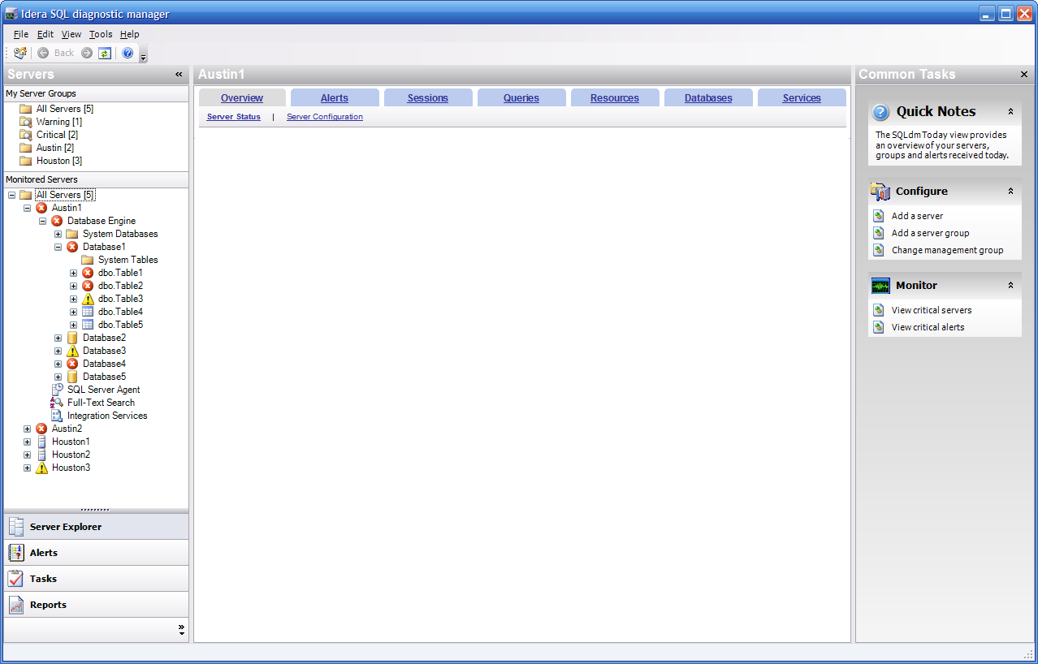
SQLdm Main Form Layout

Behavior
If a connection to a SQLdm Server has not or cannot be established, the Getting Started view will be shown only; the Navigation and Task panes will be disabled.

Menu (include in prototype)
The main menu has the following structure (refer to the associated menu section for further details):

File  Connect…  ----------------------  Add →  Server…  Server Group…  Remove (DEL)  ----------------------  Properties…  ----------------------  Print Preview  Print  ----------------------  Manage License  ----------------------  Exit | View  Refresh (F5)  Pause  --------------------------  Navigation Pane  Task Pane  --------------------------  Show Hidden Groups  --------------------------  Back  Forward | Go  Servers  Alerts  Tasks  Reports | Tools  Idera Products  -------------------------------------------  Product Utilities  -------------------------------------------  Configure Notification Providers…  -------------------------------------------  Console Options… | Help  Help on this Window (F1)  ---------------------------------  How Do I →  ---------------------------------  Search  Contents  Index  ---------------------------------  Check for Updates  System Diagnostics  Search Knowledge Base  Contact Support  About Idera Products  ---------------------------------  About Idera SQLdm

File
The following options will be available from the File menu:
- Connect… – launches the Connect to SQLdm Database dialog.
- Add Server… – launches the Add Server dialog. This option is only visible if a connection to a SQLdm Server has been established.
- Add Server Group… – launches the Add Server Group dialog. This option is only visible if a connection to a SQLdm Server has been established.
- Remove (DEL) – removes the selected server or group. This option is only visible if a connection to a SQLdm Server has been established and is only enabled if a server or group is selected. A warning message will be presented to the user confirming the removal since metrics will no longer be collected. This option can also be accessed via the Delete key.
- Properties – launches the Server Group or Server Properties dialog depending on which is selected. This option is only visible if a connection to a SQLdm Server has been established and is only enabled if a server or group is selected.
- Print Preview – launches the native Print Preview dialog supported in .Net. This context of this dialog will be bound to the active main view.
- Print – launches the native Print dialog support in .Net. The context of this dialog will be bound to the active main view
- Manage License – launches the Manage License dialog
- Exit – closes the connection to the SQLdm Server and exits the desktop client application.

View
The following options will be available from the View menu:
- Refresh (F5) – refreshes the current view. This option will only be available a view that can be refreshed is active. This option can also be accessed via the F5 key.
- Pause – pauses automatic refreshes for the current view.
- Navigation Pane (checkbox) – hides/shows the Navigation Pane. A checkbox presents the current visible status. This option can be toggled via the ALT+F1 key.
- Task Pane (checkbox) – hides/shows the Task Pane. A checkbox presents the current visible status. This option can also be toggled via ALT+F2 key.
- Show Hidden Server Groups – hides/shows hidden server groups. Server groups can be hidden rather than deleted if so desired. This options provides the ability to expose hidden server groups in case they should be re-shown.
- Back – navigates the current main view back to the previous view. This option will only be available if a SQLdm Server connection is established and view history exists. This option can also be accessed via the Backspace key.
- Forward – navigates the current main view forward to the last active view before a Back navigation. There are two stacks maintained for back and forward navigation in case you’re confused at this point. This option will only be available if a SQLdm Server connection is established and forward view history exists.

Go
Since we’re providing the Outlook 2003 navigation pane, we’ll also provide a similar menu for navigating among pane options since it’s possible that the Navigation Pane may be hidden (refer to Outlook if you don’t know what I’m talking about). The selected option navigates to the respective pane. These options are only available if a SQLdm Server connection is established. Each of these menu options can also be toggled via the respective CTRL+# key, starting with 1 and running through the number of available pane options.

Tools
The following options will be available from the Tools menu:
- Other Idera Products – a registry key is created for each installed Idera product. When the desktop client is launched, it’ll read the parent registry key to determine the other products that are installed and list them in this area of the Tools menu; therefore, these options are dynamic. Whenever another product option is selected, it’ll be launched as a separate process.
- Other Product Utilities – a registry key is created for other product specific utilities than may be installed with the desktop client. At this point, these are undetermined, but will be listed in this area of the Tools menu. The selected utility will be launched as a separate process.
- Configure Notification Providers… - launches the Configure Notification Providers dialog.
- Options… - launches the Console Options dialog.

Help
The following options will be available from the Help menu:
- Help on this Window (F1) – launches the context specific help for the active view. This option can also be accessed by pressing the F1 key.
- Getting Started
- How Do I… - this option will list a few high-level help topics, which haven’t yet been determined.
- Search – launches the help file, with the Search tab selected.
- Contents – launches the help file, with the Contents tab selected.
- Index – launches the help file, with the Index tab selected.
- Check for Updates – launches the default web browser to the appropriate SQLdm version check web link.
- System Diagnostics – launches the System Diagnostics dialog
- Search Knowledge Base – launches the default web browser to the Idera knowledge base web link.
- Contact Support – launches the default web browser to the Idera support web link.
- About Idera Products – launches the default web browser to the Idera web site.
- About Idera SQLdm - launches the About Idera SQLdm dialog.

Toolbar(s) (include in prototype)
At this point, we only plan to support one main toolbar. Other contextual toolbars may be added as warranted.

Main Toolbar
The following options will be available from the main toolbar:
- SQLdm Today – navigates the main view to the SQLdm Today view.
- Back – navigates to the last view. The same rules apply here as described in the main menu above.
- Forward – navigates to the previous view if a Back navigation has occurred. The same rules apply here as described in the main menu above.
- Pause – pauses automatic refreshes for the active view.
- Refresh – refreshes the active view.
- Help – launches the help file, with the Contents tab selected.

Navigation Pane
The Navigation Pane is based on the Outlook 2003 navigation pane and allows the following navigation options:
- Server Explorer
- Alerts
- Tasks
- Reports

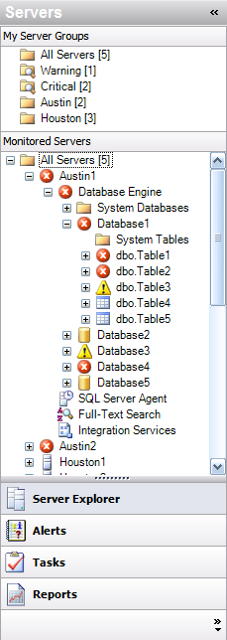
SQLdm Navigation Pane

Each of these options is described in detail in the proceeding sections of this specification.
In addition to the aforementioned navigation options, the Navigation Pane also has the following features:
- A close button for hiding the Navigation Pane. It can be reopened via the main menu.
- The navigation options can be collapsed to provide more real estate for the contextual view.

Main View Pane
The main view pane presents the context specific view driven initially by the selections made in the Navigation Pane. Drill-down views are also shown in this pane where appropriate. For details, refer to the 4.1.x sections below.
These views are refreshed automatically based on the interval configured in the Console Options dialog, or can be manually refreshed via to menu or toolbar options.

Task Pane
NOTE: This pane is considered a rider and will likely not be included in the final design due to screen real-estate concerns.
The task pane is the tertiary pane available on the right side of the main form, which provides context sensitive options based on the active view in the main view pane. This pane is conceptually the same as the Task Pane available in Microsoft Office products and will have similar design, as shown below:

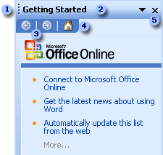
Microsoft Office Task Pane

- The Task Pane can be moved if the user so desires (this is a nice-to-have feature that we may support depending on time constraints).
- Alternative task panes are available via the Other Task Panes list that will drop down when the tasks pane title is selected. Details of each of these optional panes are provided in the sub-sections below.
- Navigation among previously selected panes may be available (this is a feature that we may support depending on time constraints).
- The Home button would simply navigate back to the Getting Started task pane. This option will only be available if we choose to implement #3.
- The Task Pane can be closed (hidden) by clicking the Close button. It can be reopened via the Task Pane option on the View menu.

Getting Started
The Getting Started task pane will provide links to common operations in context with the active view. For example, if the SQLdm Today view is visible, operations such as “Add Server” or “Check for Updates” would be available. Links to high level help topics could also be provided in this task pane.

Help
The Help task pane will provide help search and a link to the table of contents. Knowledge base and support links would also be provided here.

To-Do List
Recent and up-coming to-do items will be listed on this task pane. These items will be based on those generated or created in the Tasks navigation pane.

Actions
The Actions task pane will provide links to actions in context with the current view. For example, actions such as “Ping Server” or “Stop Server” would be listed here if the Server Monitor view were active. Details of available actions will be determined at a later date, but you get the idea.

History
For views that support historical snapshots, the History task pane will list available snapshots that can be viewed. Each snapshot will contain at a minimum the collection date, in addition to a brief description of the server state when available. Views that support historical snapshots will be noted in their respective sections below.

Getting Started
The Getting Started view will be similar to that provided in the existing desktop client. The purpose of this view is to highlight common tasks and help topics that may be important to users when first setting up or learning about product features. This view is the default view shown in SQLdm until at least one monitored server has been added; at that point, the SQLdm Today view becomes the default.
A list of the five most recently monitored servers will be listed in this view if a SQLdm Server connection has been established.

Server Explorer

Navigation Pane
Description
The navigation pane for the Server Explorer lists monitored servers and groups as shown below. Server groups can be dynamic (based on custom filters) or static (servers are explicitly added or removed). Refer to the Add Server Group dialog for detailed server group options. Several server groups will be included by default:
- All Servers – contains all monitored servers.
- Critical – dynamic group that contains all monitored servers in critical state.
- Warning – dynamic group that contains all monitored server in warning state.

Clicking on a server group lists its collection of servers in the Monitored Servers tree. Each monitored server will list hosted databases, as well as respective tables and indexes. The status icon shown for the server will be based on the most critical state of any descendant object.

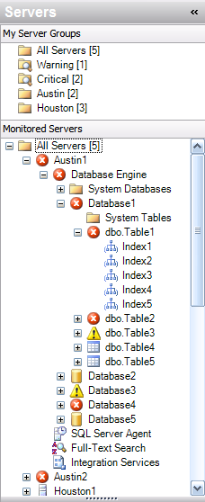
Server Explorer Navigation Pane

Behavior
No server group or server is selected by default since the SQLdm Today view is the startup view and it isn’t tied to a particular server group.
Clicking on any node in the tree will navigate to the default view for that object. For example, clicking on a server node will show the Server Monitor view for the selected server, clicking on a database node will show the Databases Summary view for the selected database, clicking on a table node will show the Databases > Tables view for the selected table, etc.
A benefit of this behavior is that the user can navigate to the desired object without having to drill-down through views that may not be relevant to the problem being diagnosed. In the existing desktop client, four views must be generated just to list table indexes. In addition, the tree offers natural filtering for some views, such as Oldest Open Transactions, which can be filtered on the database in question without having to query on all databases.
Right clicking on a node will launch the appropriate context menu:
- Server Group
  - Add – launches the Add Server Group dialog
  - Remove – removes the selected server group
  - Properties – launches the Server Group Properties dialog
  - Hide – hides the server group. Hidden server groups can be shown by selected the View > Show Hidden Server Groups on the main menu.
  - Contextual view
- Server
  - Add – launches the Add Server dialog
  - Remove – removed the selected server
  - Properties – launches the Server Properties dialog
  - Contextual views
- Database/Table/Index
  - Contextual views
Notes
- Service status will not be listed in the server tree as shown in the graphic. The Server Monitor and Services Summary view will provide this information.

SQLdm Today View (include in prototype)
Description
After the user has added at least one monitored, the SQLdm Today view becomes the default view shown when opening the desktop client. You can think of this view as a high-level triage view, illustrating the current state of all monitored SQL Servers and noting the most critical servers and alerts.
As illustrated below, the SQLdm Today view has three primary panels (descriptions are provided in the graphic):
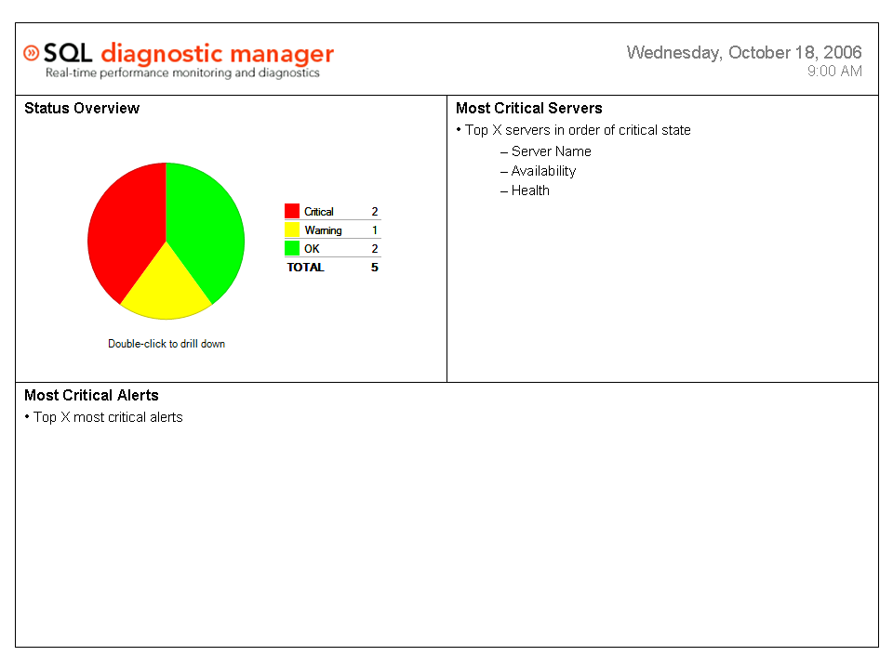SQLdm Today View Layout

Behavior
The user has three main options to navigate from this view:
- Clicking on a Status Overview pie chart will navigate to the appropriate Server Group view.
  - Note that this control will likely change to a simply single graphic indicating the overall system status, including:
    - Green check mark – all monitored server are OK
    - Yellow yield sign – one or more servers are in a Warning state
    - Red error sign – one or more servers are in a Critical state
    - Unavailable sign – the SQLdm Database is not configured or a connection cannot be established
- Clicking on a server in the Most Critical Severs list will navigate to the appropriate Server Monitor view.
- Clicking on an alert on the Recent Alerts list will navigate to the appropriate contextual view for resolving the alert. Alerts are bound to specific metrics, so if the alert were for a blocked process, clicking on the alert would navigate to the Blocking processes view for the server running the process.
- Common Tasks
  - Monitor New Server(s)
  - Configure Alerts
  - Manage Tasks
  - Generate Reports
Use Cases
- The primary use case for this view is the initial server triage. From this view, the user should be able to quickly see the overall state of all monitored servers and which servers are most critical. From that point, the user can drill-down to the group of servers that are in a specific state, or single out a particularly critical server. The user can also see recent alerts that may need attention.

Server Group View (include in prototype)
Description
The Server Group view shows a list of all servers included in a selected group. The following view modes will be supported:
- Mini-Monitors – this view will list monitors similar to the Server Monitor view, but on a smaller scale. Once the Server Monitor view is prototyped, more details for this view will be available.
- Icons – this view will list server status icons similar to the 30% view in the exiting SQLdm desktop client. The status icon shown in the server tree will be overlaid on a general server icon.
- Details – this view will be in the form of a grid view, listing selected metrics similar to that of the server listing details view in the existing SQLdm desktop client.
Behavior
Alternative views will either be available via tabs at the top of the main view or via context menu. Regardless of the selected view, double-clicking on any server will navigate to the Server Monitor view for the selected server. Right-clicking on a server will present a context menu for the selected server similar to that detailed in the Navigation Pane.
The Details grid will provide column filtering and grouping similar to that provided in other new Idera products. The list of metrics provided in this grid will be similar, if not the same, as the existing desktop client. Any changes will be noted at a later time.

Server View (include tab navigation in prototype)
The Server view is the most dramatic change from the existing desktop client. A new tab metaphor has been adopted to better organize the various views available for monitoring and diagnosing SQL Server performance problems. After studying a number of documents and articles provided by Microsoft Product Support Services, Microsoft Development and independent DBAs, a common theme for approaching troubleshooting SQL Server performance problems became apparent; each document broke down SQL Server performance problems into key symptom “areas.” The organization of the tabs reflects these areas, with several contextual views provided for each. Details of each area and its views are provided in the following sections of the specification.

Where are my alerts, or what the F@%K are you thinking?
One thing to point out is that there is no SQLdm Alerts tab for server specific alerts. This is not an oversight. Alerts, like Server Monitoring, is a top-level feature of SQLdm; therefore, it has its own pane in the Outlook Navigation Pane, just like Server Explorer and Reports. Many of the server views will provide a list of recent, context-specific alerts, or provide alert threshold indicators. For example, the Server Monitor view will contain an in-line popup of recent alerts, as well as provide visual controls that indicate metric threshold violations, such as high CPU Usage. In addition, each tab of the Server view will provide a visual indicator when alerts are outstanding for that area, as shown below.

Sessions
Queries
Databases
Services
Logs
Resources
Overview
Monitor | Details | Configuration
Server View Tabs with Alert Indicators

An Important Note about Historical Data in Real-Time Views
Many of the Server views provide historical graphs for collected metrics. These graphs are not intended to be used for historical reporting, since the Server views are designed for real-time diagnosis and troubleshooting. For performance reasons, these graphs will be limited to no more than 24 hours of data points (refer to the Console Options dialog for more details) for any given metric.
For historical reporting over any period for which data has been collected, users will be directed to the Reports feature of SQLdm. Many of the same graphs will be available, but time ranges can be selected over the entire time that metrics have been collected and stored in the SQLdm Database.

Common Graph Look-And-Feel
ChartFX will be used to present all graphs in the Server views. The following graph is a sample of the general look-and-feel of the ChartFX graph control:

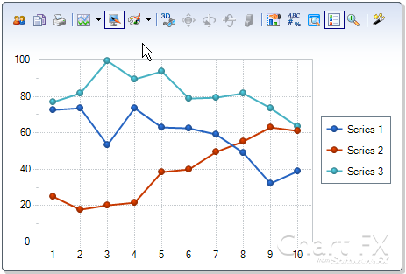
ChartFX Graph Control

By default, the toolbar shown at the top of the graph will be hidden. A context menu will be provided for each graph and will list the following general options:
- Maximize – this option would maximize the graph to take up the entire active view area. A restore option would then be provided to restore the graph to its original size.
- Print – prints the selected graph
- Export – provides export options for the selected graph, such as saving as an image or exporting series data
- Show Toolbar – shows the toolbar for the selected graph, which provides advanced properties
- Metrics – launches a dialog that lists the metrics shown in the graph. Metrics can be enabled or disabled based on user preferences.
- Help – shows popup help about the selected graph

Overview Tab
The first tab of the Server view provides several high-level views of the current state and configuration of the monitored SQL Server, including:
- Monitor – shows a high-level view of the state of the SQL Server and the dataflow among architectural components. This view is intended to complete with the Spotlight Home page.
- Details – shows a list of collected metrics, their current values and their current state based on defined thresholds.
- Configuration – shows a list of the current SQL Server configuration options and allows the user to modify variable values.

Sessions
Queries
Databases
Services
Logs
Resources
Overview
Monitor | Details | Configuration
Server Overview Tab

Monitor (include in prototype)
Description
The Monitor view is intended to compete with Spotlight’s Home Page. This view will show important metrics organized into key performance areas, with each metric existing in a control that will reflect its current threshold state for quick visual queues. In addition, visual data flows will be represented between each key performance area. These key performance areas will be organized in a similar fashion to the Server tabs. The Spotlight Home Page is shown below; a screenshot of our prototype will be included when available.

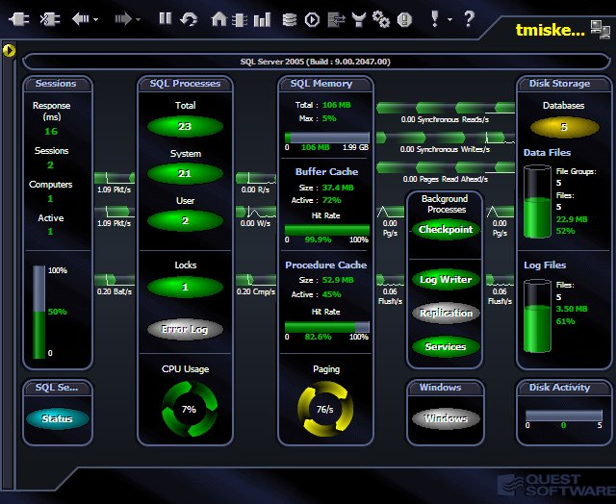
Quest Spotlight Home Page – We need to compete with this!
Behavior
This view needs to seem alive and active, just like a heart monitor hooked up to a patient in the hospital. Spotlight has done a very good job of simulating the illusion of activity by creating controls that simulate motion based on static data points; the higher the data point, the faster the control moves; the lower the data point, the slower the control moves. In addition, each control provides a color matching the threshold violation; red = critical, yellow = warning, green = ok, etc. We’ll need to provide similar behavior.
Clicking on a metric control will navigate to a default contextual view. For example, clicking on the Response Time control would navigate to the Sessions Summary view.

Details
Description
The Details view provides a list view of all collected server metrics where threshold have been provided, including the following columns:
- Metric Name – descriptive name of the server metric
- Value – last sample value for the metric
- Units – unit of measurement
- Flag – flag for the sample value based on defined thresholds
- Reference Range – this could be defined thresholds for the metric, or a calculated range of values based on “normal” operation of the monitored server over some period of time
Behavior
Double-clicking on a metric will navigate to the default view associated with that metric. For example, clicking on CPU Usage % would navigate to the Resources > CPU view.
Right-clicking on a metric will launch a context menu with the following options:
- Show History – shows history graph in a separate dialog (last hour of snapshots by default)
- Properties – launches the Metric Properties dialog
This grid will not provide column filtering, sorting or group by features.
Notes
- The easiest reference range to provide is the defined thresholds; however these values would give no useful information as to the “normal” range of values for a given monitored metric. It should be easy enough for us to create a view that calculates statistics for these values over time, but further research as to the amount of time it would take to implement such a view is necessary.

Configuration
Description
The Server Configuration view will show static and variable configuration values in a grid view. The following SQL Server query will list all values available in this view:
exec sp_configure
Static configuration information will be provided at the top of the view, including:
- Instance Name
- SQL Server Product
- SQL Server Version
- Operating System
- Platform
- Number of Processors
- Physical Memory
- Clustered
- Language
- Collation
Variable configuration options will be listed in the grid, including the following columns:
- Name – name of the configuration option
- Value – configured value for the configuration option
- Minimum – minimum value for the configuration option
- Maximum – maximum value for the configuration option
- Value In Use – running value currently in effect for the configuration option
- Is Dynamic – updated values take effect when the RECONFIGURE statement is executed; otherwise a restart of the SQL Server database engine is required
- Description – description of the configuration option
A text box will be provided for changing a selected configuration option.
Behavior
The grid view will be sortable, but columns cannot be filtered or grouped.
If a configuration option is changed to a value outside the Minimum and Maximum range, a warning dialog will be presented to ask if the RECONFIGURE WITH OVERRIDE should be executed, since SQL Server does support but warns against changing configuration options outside the recommended range.

Sessions Tab
The Sessions tab provides views for monitoring and diagnosing problems with sessions established to the monitored SQL Server. A session can be an internal (system) or client connection to a SQL Server that is established to execute requests (queries). The views available in the sessions tab are organized around common problem areas.
The following tab structure will be presented when the Sessions tab is selected:

Overview
Queries
Databases
Services
Logs
Resources
Sessions
Summary | Details | Locks | Blocking | Oldest Open Transactions
Sessions Tab

A note about terminology: Sessions vs. Processes
SQL Server has updated its terminology regarding “sessions” and “processes.” In the past, the difference between the two has been arbitrary. It appears based on the current SQL Server documentation that the term “sessions” has become the standard, and many of the new dynamic management views built into SQL Server for collecting diagnostic information exclusively refer to “sessions” rather than “processes.” In addition, as we move toward including more OS metrics, the term processes could become confusing, since we may want to list NT processes. For this reason, I have opted to use the term “sessions” over “processes.”

Summary
Description
The Summary view provides an overview of information related to SQL Server sessions. This view will be organized into four quadrants, including the following:
- Response Time chart – a line graph of the response time of the monitored SQL Server in milliseconds. The response time calculation is based on the query specified in the Server Properties dialog.
- Sessions chart – an area graph of the system and client sessions established to the monitored SQL Server. The following metrics will be included in the graph:
  - Active – active user sessions
  - Idle – idle user sessions
  - System – internal system sessions
- Total Locks by Type chart – a line graph of the total locks by type. The following metrics will be included:
  - AllocUnit
  - Application
  - Database
  - Extent
  - File
  - HoBT
  - Key
  - Metadata
  - Object
  - Page
  - RID
- Blocked Processes chart – a line graph of the number of blocked processes, including the number of lead blockers. A lead blocker is the root of a blocking tree.
Behavior
The following key behavior should be noted:
- All graphs listed in this view will be bound to the historical limits specified in the Console Options dialog.
- The behavior of each graph is described in the Common Graph Look-And-Feel section.

Details
Description
The Sessions > Details view provides a list of all sessions established with the monitored SQL Server. This information is presented in a grid with the following default columns:
- Session ID – SQL Server session ID
- User – ID of the user who established the session
- Host – name of the workstation from which the session was established
- Database – name of the database currently being used by the session
- Status – status of the session (running, runnable, sleeping, background, suspended, other)
- Open Transactions – number of open transactions for the session
- Command – command currently being executed by the session
- Application – name of the application specified by the session connection info
- Wait Time – current wait time in milliseconds. If the session is not waiting, the wait time with be zero
- Wait Type – the name of the last or current wait type
- Wait Resource – the name of the last or current wait resource
- CPU – cumulative CPU time for the session
- Physical I/O – cumulative disk reads and writes for the session
- Memory Usage – number of pages in the procedure cache that are currently allocated to the session. A negative number indicates that the session is freeing memory allocated by another session.
- Login Time – time at which a client session logged into the server. For system sessions, the time at which SQL Server startup occurred is displayed.
- Last Batch - last time a client session executed a remote stored procedure call or an EXECUTE statement. For system sessions, the displayed time is that at which SQL Server startup occurred.
- Blocked By – the session ID of the blocking session
- Blocking – session ID of the sessions being blocked
- Net Library – the name of the session’s client network library

A checkbox will be provided to hide/show active sessions only; if checked, only active sessions will be shown. Additional filter options will be available based on the date collected for each session. This filter dialog will likely have a similar look-and-feel as that provided by the Activity Monitor in SQL Server Management Studio (shown below).
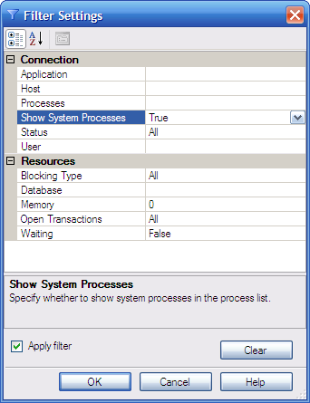
SQL Server Management Studio Activity Monitor Filter Settings Dialog

If a session is selected, an embedded pane will display at the bottom of the view providing more details about the selected session. This pane will contain the following tabbed sub-views:
- Session Details
  - This sub-view will provide an easy-to-read layout of the data shown for the session in the grid. In addition, the most recent SQL statement that was run by the session will be provided in a textbox.
- Session Trace
  - This sub-view will provide a trace of the SQL statements executed by the selected session. Each trace event will include:
    - Duration of the statement
    - CPU time in milliseconds
    - Logical reads from physical disk or memory
    - Writes to the physical disk

The following events are captured and displayed in a grid form:
    - Batch starts and ends
    - Procedure starts and ends
    - Is the anything I’m missing here???
- Session Locks
  - This sub-view will show a grid of all locks currently help by the session. The following columns will be provided:
    - Lock Type
    - Lock Mode
    - Status
    - Database
    - Table
    - Index
    - Resource
Behavior
The following key behavioral characteristics should be noted:
- Only single sessions selections will be supported.
- The user will be provided an option to kill a session. A warning message will be presented prior to killing the session.
- The grid will support sorting, group by and column filtering.

Locks
Description
The Sessions > Locks view provides information about all currently help or requested locks. Locks will be listed in a grid, including the following columns:
- Session ID
- Scope
- Database
- Object
- Request Mode
- Request Type
- Request Status
- User
- Host
- Application

The user will be allowed to filter any of the columns provided.
In addition to the list of current locks, the following graphs will be included in two panels across the bottom of the view:
- Lock Types chart – this is a multi-select graph that allows the user to view the lock counter of interest. The following will be available.
  - Total – this is actually not a counter, but the total number of each lock type at the time of the collection.
  - Lock Requests/sec
  - Lock Timeouts/sec
  - Number of Deadlocks/sec
  - Lock Waits/sec
  - Lock Wait Time (ms)
  - Average Wait Time (ms)
  - Average Wait Time Base
  - Lock Timeouts (timeout > 0)/sec

Each counter graph will include a series for each lock type, including:
  - AllocUnit
  - Application
  - Database
  - Extent
  - File
  - HoBT
  - Key
  - Metadata
  - Object
  - Page
  - RID
- Latches chart – this is line graph shows recent counter history for internal SQL Server locks. These locks should typically be help for a short period of time. The following counter metrics will be shown:
  - Latch Waits/sec
  - Total Wait Time (ms)

Behavior
The following key behavioral characteristics should be noted:
- Only single lock selection will be supported.
- The locks grid will provide column sort, group by and filtering.
- Graphs will abide by the behavior outlined in the Common Graph Look-And-Feel section.
- The following context menu options will be provided when right-clicking on a selected lock:
  - View Session Details
  - Kill Session
  - Filter
  - Help

Blocking
Description
The Sessions > Blocking view presents the current blocking chain(s) that exist as a result of sessions waiting on locks held by other sessions. This view can also be used to diagnose deadlocks. Blocking can result in long running queries and timeouts. The blocking chain(s) will be displayed in a tree grid view. The lead blocker will be at the root of the tree, with waiting sessions listed as child nodes. The following columns will be available for each blocking or blocked session:
- Session ID
- Scope
- Database
- Object
- Request Mode
- Request Type
- Request Status
- Wait Duration
- User
- Host
- Application

In addition to the blocking chain(s) grid, a line graph of the blocking and blocked sessions will be displayed at the bottom of the view. The following metrics will be included:
- Lead Blockers – the number of root blocking sessions
- Blocked Sessions – the total number of blocked sessions

Behavior
The following key behavioral characteristics should be noted:
- The blocking chain(s) grid will provide column sorting and filtering, but not group by since it wouldn’t work with the tree form the grid must display.
- Filtering will be provided so users can filter down to the blocking chain of interest.
- The following context menu options will be available for the blocking chain(s) grid:
  - View Session Details
  - Kill Session
  - Filter
  - Help

Oldest Open Transactions
Description
The Sessions > Oldest Open Transactions view displays a list of the oldest open transactions for the monitored SQL Server. Long running transactions can be a symptom of performance problems. Oldest open transactions are gathered for each individual database hosted on the monitored SQL Server. The existing SQLdm desktop client only allowed for collecting this information for all databases, which could be performance intensive if the server was hosting many databases. For this reason, the user will have several options for filtering down to the database(s) of interest:
- The user can select the database of interest in the server tree, right-click and navigate to the Oldest Open Transactions view.
- The user can use the filter dialog provided in the Oldest Open Transactions view to filter down to the database or set of databases of interest.

The following columns will be available in the Oldest Open Transactions grid:
- Session ID
- Database
- User
- Host
- Application
- Running Since
- Run Time
- Command

Behavior
The following key behavioral characteristics should be noted:
- The grid view will provide column sorting, group by and filtering
- Advanced filtering options will be available for filtering data collection as well as collected data.
- The following context menu options will be available from the grid view:
  - View Session Details
  - Kill Session
  - Filter
  - Help

Notes
- I think we should remove this view. We can only collect the single oldest open transaction for a given database, so I think we should simply list the SPID associated with the oldest open transaction as part of the details we list. The user could then right-click and navigate to the Sessions > Details view for more detailed information about that SPID since that’s the right view to be diagnosing active session problems anyway.

Queries Tab
The primary purpose of the Queries tab is to provide views for analyzing data captured by the Query Monitor Trace. The events and threshold configuration of the Query Monitor trace can be customized via the Server Properties dialog.

Sessions
Overview
Databases
Services
Logs
Resources
Queries
Monitor | Execute
Queries Tab

Monitor
The Queries > Monitor view operates similarly to SQL Server Profiler, but with several additional features for better query analysis. This view is a combination of both our existing Worst Performing and Most Frequent query monitor views, since the data for both is duplicated.
All data shown in this view is based on the event and threshold configuration of the Query Monitor Trace. Each of the following event types can be captured:
- Stored Procedure and Trigger executions
  - Capture SP:Completed (43) events, which occur when a stored procedure has completed.
- SQL Statement executions
  - Captures SQL:StmtCompleted (41) and SP:StmtCompleted (45) events, which occur when a T-SQL statement has completed or when a T-SQL statement within a stored procedure has completed, respectively.
- SQL Batch executions
  - Captures SQL:BatchCompleted (12) events, which occur when a T-SQL batch has completed.

The following thresholds can be configured and an event will only be captured if the criterion for all thresholds is met:
- Duration – the number of seconds an event must run before being captured by the trace. A minimum of .5 seconds can be specified.
- CPU Time – the number of seconds in CPU time an event must exceed before being captured. A value of zero can be specified if this threshold is to be ignored.
- Logical Reads – the number of logical reads that must be exceeded before an event is captured. A value of zero can be specified if this threshold is to be ignored.
- Physical Writes – the number of physical writes that must be exceeded before an event is captured. A value of zero can be specified if this threshold is to be ignored.

The view will provide two panels for analyzing captured events:
- A grid will be displayed at the top of the view listing each captured event based on the filter criteria. The columns of this grid can be sorted, grouped by and filtered. The following data columns will be available:
  - Completion Time
  - Event Type
  - Session ID
  - Duration
  - CPU Time
  - Reads
  - Writes
  - Host
  - Application
  - Windows User
  - SQL User
  - Database
  - SQL Statement
- A chart will be displayed at the bottom of the view showing a history of the total number of each event type captured over the selected time period. We don’t currently provide such a chart, but this could be critical for showing spikes for specific event types, which would allow users to target more isolated time periods where query performance becomes a problem.

Since the SQL Statements can be quite large, double clicking on an event entry will launch a dialog with a easy-to-read layout of the event information.
In order to isolate the data most crucial to diagnosing query performance problems, the following dynamic filtering options will be available (these options do not impact the events captured by the trace, only which event are displayed):
- Date range
- Time period
- Application name
- Host name
- Database name
- Windows username
- SQL username
- SQL text
- Duration
- Executions

Behavior
The following behavioral characteristics should be noted:
- By default, events captured for the current day will be displayed in order to increase the performance of the initial load of the view. Depending on the thresholds configured for the trace, the number of events captured can become quite large, so performance is a concern.
- If the user chooses to group by SQL text, the number of executions will be listed, as well as total and average duration, CPU time, reads and writes.
- If the Query Monitor Trace is disabled, this Monitor view will still be available to view historical data, however, a message will be displayed indicating that the Query Monitor Trace is disabled.

Notes
- We should consider providing limit options on the number of records we would retrieve for the specified criteria to improve performance. This is probably an option we should consider for other grids as well.

Execute (this is a rider for 5.0 and not currently scheduled)
Description
The Queries > Execute view will provide for basic query execution and viewing of result sets. This view serves two purposes:
- Queries can be executed for the purpose of testing and monitoring performance via other SQLdm views.
- Actions can be taken using queries that may not be supported as part of a native view, such as reorganizing a fragmented index.

This view would work much like Query Analyzer and have a similar layout:
- Query panel – this panel would be a rich-edit textbox for entering the text of a query
- Results panel – this panel would appear at the bottom of the view once a query is executed, including a tab for results and a tab for messages. The results tab can be presented in the form of a grid or text.

Behavior
The behavior of the Execute Query view would be basically the same as that of Query Analyzer, with more restricted options (i.e., no support for analyzing execution plans, etc.). This view is provided purely for the purpose of executing queries and viewing result sets.

Resources Tab
The Resources tab provides views for monitoring SQL Server and system resource usage. Resource bottlenecks are often the cause of SQL Server performance problems. These bottlenecks can be the result of poor database application design or point to other system processes eating up valuable resources needed by SQL Server. Resource bottlenecks fall into the following categories:
- CPU
- Memory
- Disk

All views provided in the Resources tab present aggregations of counters that can be used to isolate resource bottlenecks.
TODO: All of these views need to include best practice information so users know which limits need attention. For example, Total CPU Usage of higher than 80% needs attention, Processor Queue Length of ~2 is considered high, etc.
This is a good link for best practice guidelines (and where many of the ideas outlined here came from): http://msdn2.microsoft.com/en-gb/library/ms191246.aspx

General Notes about Behavior
The following general behavioral characteristics should be noted regarding the Resource views:
- All graphs presented here will provide the same look-and-feel and behavior as outlined in the Common Graph Look-And-Feel section.
- Graph history is bound to the limits set in the Console Options dialog.

Summary
The Resources > Summary view provides high-level graphs related to overall resource usage. These graphs include counters pertaining to system resources, as well as SQL Server. The view will be laid out in a table form with two columns and three rows, including the following graphs:
- CPU Usage
  - Total
  - SQL Server
- Call Rates
  - Batches
  - Compiles
  - Re-Compiles
- Memory Usage (max value = total memory)
  - SQL Server
  - Should we show available bytes???
- Cache Hit Rates
  - Buffer Cache
  - Procedure Cache
- Disk Usage
  - % Disk Time
- SQL Server I/O: multi-select
  - Physical I/O
    - Checkpoint Writes
    - Lazy Writer Writes
    - Read Ahead Reads
    - Synchronous Reads
    - Synchronous Writes
  - Logical I/O
    - Logical Reads
    - Logical Writes

The main objective of this view is to isolate the resource bottleneck, which could be CPU, Memory or Disk, but could also be correlated between different resource categories. From this view, the user can drill down into the resource view that is deemed most applicable.

CPU
The Resources > CPU view provides several graphs for monitoring CPU Usage at both the system and SQL Server level. This view is laid out in table form with two columns and two rows, including the following graphs:
- CPU Usage
  - Total
  - SQL Server
- Processor Queue Length
- Processor Time
  - % Privileged Time
  - % User Time
- Call Rates
  - Batches
  - Compiles
  - Re-Compiles

Memory
The Resources> Memory view provides several graphs for monitoring Memory Usage at both the system and SQL Server level. This view is laid out in table form with two columns and three rows, including the following graphs:
- Memory Usage (max value = total memory)
  - SQL Server
  - Should we show available bytes???
- Paging
  - Memory: Pages\sec
  - Memory: Page Faults\sec
  - Process: Page Faults\sec (SQL Server)
- Memory Areas (MB) (area graph)
  - Buffer Cache
  - Procedure Cache
  - Optimizer Code
  - Lock Area
  - User Connections
  - Sort, Hash, Index
  - Pinned Tables
  - Free List
- Cache Hit Rates
  - Buffer Cache
  - Procedure Cache
- Buffer Cache (MB) (area graph)
  - Active Pages
  - Free Pages
- Procedure Cache (MB) (area graph)
  - Active Pages
  - Free Pages

Procedure Cache
The Resources > Procedure Cache view allows users to see exactly what is stored currently in the monitored SQL Server Procedure Cache. A grid will be presented at the top of the view listing all procedure cache objects, including the following data columns:
- Type
- Size (MB)
- Usage - number of times used since stored in the cache
- References - number of other objects in cache referencing this object
- User - SQL user submitting the query
- SQL Command - name of the object or detailed SQL query submitted

At the bottom of the view, two graphs will be presented:
- Cache Size by Object Type – an area graph including the following object types:
  - Stored procedures
  - Perpared statements
  - AdHoc queries
  - Replication procedures
  - Extended procedures
  - Rules
  - Cursors
  - Triggers
  - Views
  - Default constraints
  - System tables
  - Check constraints
  - User tabs
- Object Types – multi-select graph showing the following metrics for each of the object types listed above:
  - Hit Ratio
  - Object Count
  - Use Rate

Behavior
The following behavioral characteristics should be noted:
- An option will be provided to clear the existing objects from the procedure cache.

Disk
The Resources > Disk view provides several graphs for monitoring Disk Usage at both the system and SQL Server level. This view is laid out in table form with two columns and two rows, including the following graphs:
- Disk Usage
  - % Disk Time
- Disk Queue Length
- SQL Server Physical I/O
  - Checkpoint Writes
  - Lazy Writer Writes
  - Read Ahead Reads
  - Synchronous Reads
  - Synchronous Writes
- SQL Server Logical I/O
  - Logical Reads
  - Logical Writes

Databases Tab
The Databases tab provides views for monitoring all things related to SQL Server databases, including:
- Configuration
- Capacity Usage
- Disaster Recovery
- Index Usage
- Fragmentation

Summary
Description
This Databases > Summary view provides an overview of the databases hosted on a monitored SQL Server, including the active configuration, current capacity and recent growth. At the top of the view, a grid is presented listing each database, including the following data columns:
- Database Name
- Status
- Data Size (MB)
- % Data Tables
- % Data Indexes
- % Data Unused
- % Data Free
- Data Potential Growth
- Log Size (MB)
- % Log Free
- Log Potential Growth
- Oldest Open Transaction
- Oldest Open Transaction Start Time
- Last Backup
- Last Log Checkpoint
- Date Created
- Version Compatibility
- # Tables
- # File Groups
- # Files
- Data Autogrowth – true if autogrowth enabled
- Log Autogrowth – true if autogrowth enabled
- Active Processes
- Active Options

In addition, two chart areas will be presented along the bottom of the view, including:
- Database Space – a graph of the data and log space used, which can be shown in either megabytes or percentage. This graph will include a separate series for data and log space. Each series will be displayed as a stacked bar chart, with the following items:
  - For data
    - Tables
    - Indexes
    - Unused
    - Free
  - For log
    - Used
    - Free
- Database History – multi-select graph with a series for each selected database. The following options will be available:
  - Data Size (MB)
  - Log Size (MB)
  - % Log Used
  - What other interesting metrics would we want to show here?

Behavior
The following behavioral characteristics should be noted:
- All columns in the grid view can be sorted, filtered and grouped by.
- The grid is multi-select, which allows data from several databases to be compared in the supported graphs.

Configuration
Description
The Databases > Configuration view provides information about database configuration options and properties. This view can be used to analyze configuration differences between databases or spot mistaken configuration. This view will be composed of a single grid including the following data columns:
- Database Name
- Collation
- IsAnsiNullDefault
- IsAnsiNullsEnabled
- IsAnsiPaddingEnabled
- IsAnsiWarningsEnabled
- IsArithmaticAbortEnabled
- IsAutoClose
- IsAutoCreateStatistics
- IsAutoShrink
- IsAutoUpdateStatistics
- IsCloseCursorsOnCommitEnabled
- IsFulltextEnabled
- IsInStandBy
- IsLocalCursorsDefault
- IsMergePublished
- IsNullConcat
- IsNumericRoundAbortEnabled
- IsParameterizationForced
- IsQuotedIdentifiersEnabled
- IsPublished
- IsRecursiveTriggersEnabled
- IsSubscribed
- IsSyncWithBackup
- IsTornPageDetectionEnabled
- Recovery
- Status
- Updateability
- UserAccess
- Version

Refer to SQL Server Books Online for details regarding the valid values for each of listed database properties.

Behavior
The following behavioral characteristics should be noted:
- Since the primary purpose of this view is to analyze differences or track down faulty configuration, the grid will fully support column sorting, filtering and group by.

Notes
- I’m not sure of the details of how we collect database options now, but all of the info presented in this grid can be gathered using the DatabasePropertyEx function.

Backups/Restores
Description
The Databases > Backups/Restores view provides a recent history of all backups and restored that have been performed for selected databases. This view will have two primary panels:
- Databases – a list of hosted databases for the monitored SQL Server will be shown at the top of the view, including that following data columns:
    - Database Name
    - Status
    - Data Size (MB)
    - Log Size (MB)
    - Last Backup
  - Backups/Restores – a list of recent backup and restores for the selected databases. This list can be filtered to a specified number of days in the past (default = 31 days). The following data columns will be included:
    - Type – icon representing type of backup or restore, including:
      - Full Backup
      - Differential Backup
      - Log Backup
      - Restore Database
      - Restore Log
    - Date/Time
    - Database
    - User
    - Size (MB)
    - Point In Time
    - Replace – specifies whether the restored database replaced an existing database
    - Path – the path to the location of the backup/restore file

Tables/Indexes
Description
The Databases > Tables/Indexes view displays information about tables and indexes, including capacity, dependencies and fragmentation statistics.
A dropdown will be provided for selecting a target database hosted on the monitored SQL Server.
Based on the selected database, a Tables grid view will be populated, including the following data columns:
- Table Name
- Database Name
- Owner/Schema
- # Rows
- Size (MB)
- % Database
- % Fragmentation
- % Reorganization (Scan Density) – how does this differ from % Fragmentation?
- File Group
- Date Created
- Pinned – true if pinned (kept in cache)
- BCP Table Locking
- Full-Text Catalog

Right-clicking selected table(s) provides an option to defragment indexes of selected tables.
The Tables grid view can be filtered based on any of the available data columns.
The bottom panel of this view provides three tabbed views:
- Index Statistics – this panel presents two grids:
  - Indexes – lists all indexes associated with the selected table(s), including the following data columns:
    - Index
    - Database
    - Owner/Schema
    - Table
    - Type
    - Last Stats Update
    - # Rows Modified Since Last Update
    - # Rows
    - Size (MB)
    - File Group

Right-clicking selected indexes allows for updating statistics.
  - Index Columns – lists all index columns associated with the selected index(es), including the following data columns:
    - Column
    - Average Length
    - Average Row Hits
  - Data Distribution – is this really necessary? What do people really use this for?
- Dependencies – this panel presents two grids:
  - Referenced By – lists all objects referencing the selected table(s), including the following data columns:
    - Object
    - Type
    - Action
  - References – lists all objects referenced by the selected table(s), including the following data columns:
    - Object
    - Type
    - Action

Behavior
The following behavioral characteristics should be noted:
- The tables and indexes grids are multi-select. Since this will have a performance implication when collecting data on-demand, we may want to consider providing an option to make this single-select.

Files
Description
The Databases > Files view allows users to monitor database capacity and growth, which can be the cause of throughput performance problems. This view has two primary panels:
- The top panel includes a grid of databases hosted on the monitored SQL Server, including the following data columns:
  - Database
  - Data Size (MB)
  - % Data Free
  - Log Size (MB)
  - % Log Free
  - Status
  - # Tables
  - # Indexes
  - # Files
  - # Files Groups
  - Disks
- The bottom panel is organized into a series of tabs:
  - Data Files – this panel provides information about each of the data files associated with the selected database(s). The following data will be shown:
    - A data file list will be presented at the top of the panel, including the following data columns:
      - File
      - File Group
      - Size (MB)
      - % Free
      - AutoGrow
      - Max Size
      - Growth Increment
      - Can Grow
      - Potential Growth
      - Disk Free (MB)
      - File Path
    - Two charts will be included along the bottom of the panel. Each chart will be presented as a stacked chart, including a series for each selected data file:
      - File Space (in MB or %)
        - Used Space (MB)
        - Free Space (MB)
      - Potential File Growth (in MB or %)
        - File Space (MB)
        - Potential Growth (MB)
  - File Groups – this panel provides information about each of the file groups associated with the selected database(s). The following data will be shown:
    - A file group list will be presented at the top of the panel, including the following data columns:
      - Database
      - File Group
      - # Files
      - Size (MB)
      - % Tables
      - % Indexes
      - % Unused
      - % Free
      - Can Grow
      - Potential Growth
    - Two charts will be included along the bottom of the panel. Each chart will be presented as a stacked chart, including a series for each selected file group:
      - File Group Space (in MB or %)
        - Tables (MB)
        - Indexes (MB)
        - Unused (MB)
        - Free (MB)
      - Potential File Group Growth (in MB or %)
        - Used (MB)
        - Unused (MB)
        - Potential Growth (MB)
  - Log Files - this panel provides information about each of the log files associated with the selected database(s). The following data will be shown:
    - A log file list will be presented at the top of the panel, including the following data columns:
      - File
      - Database
      - Size (MB)
      - AutoGrow
      - Max Size
      - Growth Increment
      - Can Grow
      - Potential Growth
      - File Path
    - Two charts will be included along the bottom of the panel. Each chart will be presented as a stacked chart, including a series for each selected log file:
      - File Space (in MB or %)
        - Used Space (MB)
        - Free Space (MB)
      - Potential File Growth (in MB or %)
        - File Space (MB)
        - Potential Growth (MB)
  - Transaction Logs – this panel provides information about transaction logs associated with the selected database(s). The following data will be shown:
    - A transaction log list will be presented at the top of the panel, including the following data columns:
      - Database
      - # Files
      - Size (MB)
      - % Uncommitted
      - % Not Backed Up
      - Can Grow
      - Potential Growth
    - Two charts will be included along the bottom of the panel. Each chart will be presented as a stacked chart, including a series for each selected transaction log:
      - Transaction Log Space (in MB or %)
        - Uncommitted (MB)
        - Not Backed Up (MB)
        - Free Space (MB)
      - Potential Transaction Log Growth (in MB or %)
        - Used (MB)
        - Unused (MB)
        - Potential Growth (MB)
  - Disks – this panel provides a stacked chart that illustrates the disk space used by the selected database(s). A series will be included for each disk, with each series including the following:
    - SQL Data Used
    - SQL Data Free
    - SQL Log
    - Other Files
    - Free Disk Space

Transaction Log
Description
The Transaction Log view will provide similar functionality to that provided in the existing 4.5 product. At this point, this view is limited to SQL Server 2000 support. If time permits, we’ll attempt to get this view working for SQL Server 2005 as well, but that’s considered a rider at this point.

Services Tab
The Services tab provides views for diagnosing problems with SQL Server support services, which include:
- SQL Server Agent
- Full-Text Search
- DTC
- Replication

Service Status
Description
The Service Status view provides an overview of the current status of SQL Server support services as well as a recent status history. This view is divided into two primary panels:
- The top panel shows the current status of SQL Server Support services, along with a button for affecting the current status (i.e., if the service is inactive, a button will be provided to start the service). The following support services will be listed:
  - SQL Server Agent
  - Full-Text Search
  - DTC

The following status enumeration will be supported for each service:
  - Running
  - Inactive
  - Not Installed
  - Not Configured
- The bottom panel will show a chart that indicates the recent status history for monitored SQL Server support services. This chart will be in the form of a horizontal stacked bar chart with the following representations over a given time period:
  - Running = green
  - Inactive = red
  - Not Installed = gray
  - Not Configured = blue

Behavior
The following behavioral characteristics should be noted:
- Status change buttons will only be shown for services which are installed and configured.
- If a service status change is initiated and successful, the service status button will change to the opposing action (i.e., if a service is started, the button will change to a stop button).
- If a service status change fails, a message dialog will indicate the reason.

Not Supported
- Customers have requested we provide status information regarding other SQL Server support services. The following would be likely candidates:
  - Analysis Services (OLAP)
  - Reporting Services
  - Integration Services
  - SQL Mail
  - SQL Agent Mail

SQL Agent Jobs
Description
The SQL Agent Jobs view provides details about the status of jobs hosted by SQL Server Agent on a monitored SQL Server. Not only can status be viewed, but actions can be taken such as starting or stopping existing jobs. This single view will replace our existing Job Summary and Job History views.
The SQL Agent Jobs view is composed of two primary panels:
- The top panel provides a list of all existing SQL Server Agent jobs, including the following data columns:
  - Name
  - Category
  - Enabled
  - Scheduled
  - Status
  - Last Run Outcome
  - Last Run Time
  - Last Run Duration
  - Next Run Time
  - Owner
  - Description

From this grid, the user can select a job to start or stop it depending on the current status. Clicking on a job will display the job history in the bottom panel.
- The bottom panel displays the history of a selected job. For each attempted job execution, the following data columns will be provided:
  - Run Outcome
  - Run Time
  - Run Duration
  - Retries
  - Message

An appropriate icon will be displayed depending on if the job succeeded or failed. Double-clicking on a historical job execution entry will launch a separate dialog listing the job messages that were generated for that job execution. The following data columns will be provided for each message entry:
  - Message Time
  - Message
  - Step Name
  - Step Outcome
  - Step Duration
  - Retries

The history panel can be filtering to show only failed executions if so desired.

Behavior
The following behavioral characteristics should be noted:
- Starting or stopping a job is immediate; no added scheduling will be provided.

Full-Text Search
Description
The Full-Text Search view displays data for monitoring and diagnosing problems with the SQL Server Full-Text Search service. The view is composed of a single list that displays information about each Full-Text Catalog maintained on a monitored SQL Server. The follow data columns will be provided for each catalog:
- Database – name of the database hosting the full-text catalog
- Full-Text Catalog – name of the full-text catalog
- Status – population status of the full-text catalog (Idle, Building Index, Paused)
- Last Populated – date/time the full-text catalog was last populated
- Index Size – the size of the full-text index
- Item Count – the total number of rows in all the tables included in the catalog
- Table Count – the number of tables in the catalog
- Unique Words – the number of unique words found in the catalog column rows. The larger the number of unique words, the more efficient the catalog
- Path – the full-path to the full-text catalog file

Behavior
The following behavioral characteristics should be noted:
- If the Full-Text Search service is not running, this view will be disabled.
- An icon will be presented on the rows where the Last Populated field exceeds the Full-Text Refresh metric threshold.
- User can right-click on a catalog entry and manually re-populate the full-text catalog.

Replication
Description
The Replication view provides information for monitoring and diagnosing replication difficulties. Users can view the individual transactions or SQL statements causing subscription, publishing or distribution failures. This view, for the most part, will be similar to that which we currently provide. The following data will be presented:
- Distributor – the name of the distribution server and database for the monitored SQL Server
- The following two transaction lists will be provided:
  - Unsubscribed Transactions – lists the following information about unsubscribed transactions (this view can be filtered by transaction age):
    - Subscribing Database
    - Publisher Server
    - Publisher Database
    - Distributor
    - Entry Time
    - Wait Time – the color of this field will changed depending on the Unsubscribed Transaction Wait Time metric thresholds.
    - SQL Command
  - Undistributed Transactions – lists the following information about undistributed transactions (this view can be filtered by the # of transactions):
    - Publishing Database
    - Distributor Server
    - Distributor Database
    - SQL Command

Behavior
The following behavioral characteristics should be noted:
- If replication is not configured, this view will be disabled.

Not Supported
- We’ve had a number of customer requests to improve our replication view. I’m no replication expert, but we should probably move toward a view more similar to the new Replication Monitor provided with SQL Server Management Studio 2005.

Logs
Description
The Logs tab will provide a view and filters for displaying SQL Server related logs. These logs are often used to diagnose SQL Server problems where a history of events is necessary to determine context. For the version, only the SQL Server and Agent logs will be supported. In the future, we will consider including the operating system logs as well.
The following log filter (based on that provided by SQL Server Management Studio) will be provided via toolbar and context menu (note once again that only SQL Server and SQL Agent logs will be supported in this version):

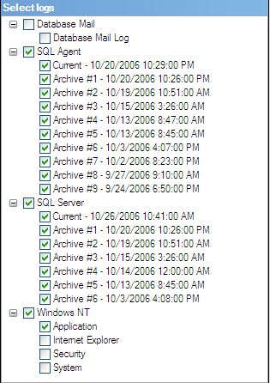
SQL Server Management Studio Log Viewer Selection Pane

By default, only the current SQL Server and SQL Agent logs will be selected. Any combination of logs can be selected, which will result in those logs being downloaded.
The log events will be displayed in a grid including the following columns:
- Severity
- Date
- Source (doesn’t apply to Agent log)
- Message
- Log Type – SQL Server or SQL Agent
- Log Source – log description

The following options will be available for this view:
- Select event log
- Filter – a dialog that provides filtering options for the selected event log(s)
- Search – a standard Find dialog that allows the user to search for text within the selected event log
- Cycle – cycles the current SQL Server event log

When an event is selected, a details panel will be displayed at the bottom of the view, providing an easy-to-read view of the event details. This panel will have an expand/collapse option.
Behavior
The following behavioral characteristics should be noted:
- Changing the selected event log(s) will entail retrieving that selected event log(s) from the monitored SQL Server. This can be performance intensive in the case that the event log is large and it has to be passed from the monitored SQL Server to the middle-tier to the desktop client. We may consider applying some of the filtering options before the event log is passed back.
- If the cycle option is selected, the current SQL Server event log will be immediately cycled on the monitored SQL Server.

Alerts
The Alerts area provides a central location for viewing all alerts raised by SQLdm for monitored SQL Servers. The SQLdm Alerts feature area is separated from the Server Explorer because it is considered a top-level feature of the desktop client; however, alerts will still be incorporated into Server Explorer views via control visualizations and alert popups, as well as the Logs view.

General Concepts
Since there are some conceptual differences between how alerts work in the exiting version of SQLdm and how they’ll work in the new version, here are some general notes on what will change and what will remain the same…
The upcoming version of SQLdm will separate the concept of alerts from that of notifications. Rather than alerts being the driver of notifications, scheduled snapshots will become the driver and alerts will simply be additional metadata about metrics collected for a snapshot. This will allow for more flexible notification rules that can be based on values other than those specified for alert thresholds. This allows alert thresholds to serve their intended purpose, which is to set a baseline for what is considered to be normal operation of a monitored SQL Server.
The upcoming version of SQLdm will also separate the concept of notification providers and destinations. This separation is critical for providers such as SMTP. In the current version of SQLdm, notification destinations are configured on a per server basis. The destination configuration for SMTP includes the SMTP server as well as the recipient(s). Because destinations and alerts are tightly coupled, this means that for any metric where SMTP notifications are enabled, the same recipient(s) will be included. This is not ideal for many of our customers that have more than one DBA on staff. These customers would like to customize this recipient list per metric. In the upcoming version of SQLdm, users will be allowed to configure notification provider instances separately from the destinations specified for any given notification rule. So, in the case of the SMTP provider, only the server and authentication information would be configured for the provider; when specifying a notification rule where an email is to be sent on a matching result, the recipient information would be specified as part of the destination information of the rule.
Finally, more robust notification rules will be supported. A notification rule is one or more conditions based on monitored server, metric alert severity, metric value or snapshot time and a set of destinations where notifications should be sent if a successful match is made. This type of notification rule will provide support for more complex filtering logic, as well as customized time windows for specific staff/role requirements.

Navigation Pane
Description
A Calendar Filter will be provided in the Navigation Pane for the Alert Log view. This filter will have a similar look-and-feel to that provided by Microsoft Outlook (shown below). The effect of this filter will be to limit the number of alerts that must be retrieved from the SQLdm Repository since the alert log can become quite large if not frequently groomed.
In addition to the Calendar Filter, other basic filter options based on the alert metadata will be provided. These filters will include at a minimum the following:
- Server
- Severity
- Date/Time
- Server
- Metric Code

Behavior
At this point, each time a new date or date range is selected on the Calendar Filter will cause a request to the SQLdm Repository. Depending on the performance of this implementation, caching of previously selected alerts may be warranted; we’ll deal with this if it becomes a problem.
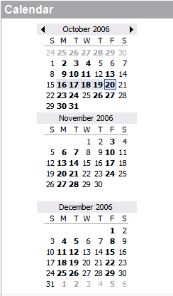
Microsoft Outlook Calendar Filter

Calendar Toolbar
Description
A calendar toolbar will be provided similar to that of Microsoft Outlook (shown below). The purpose of this toolbar is two-fold:
- Limit the period selection of the Calendar Filter.
- Limit the number of alerts retrieved from the database.

Microsoft Outlook Calendar Toolbar
Behavior
Selecting an option on this toolbar has the same effect as that provided by Microsoft Outlook; the option simply affects the range of dates selected in the Calendar Filter. For example, if a five day work week is selected, Monday thru Friday will be selected on the Calendar Filter regardless of the day selected.

Alert Log
Description
The Alert Log tab view presents a log of all SQLdm alerts that match the filter options selected. This view will have the following layout (the graphic includes descriptions of the data contained within):

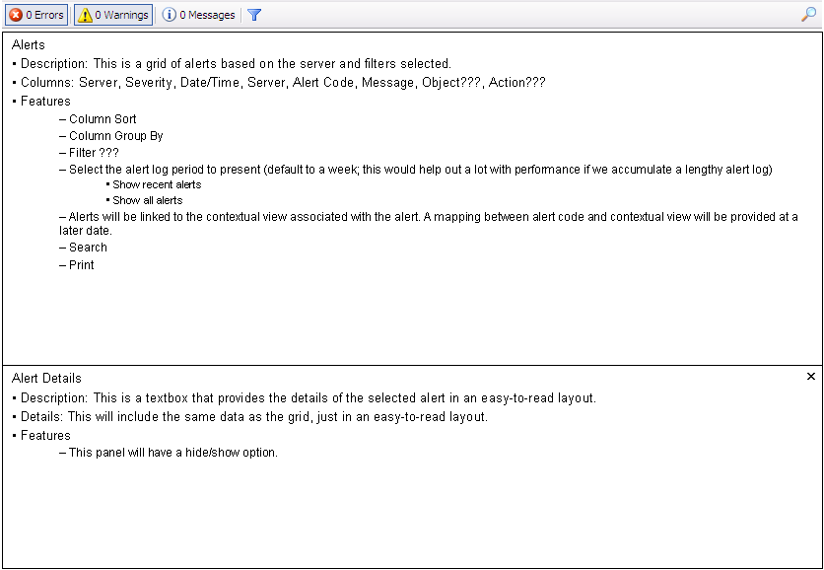
SQLdm Alert Log Layout

Behavior
The Alert Log will refresh immediately after new filters are applied. Since this view may contain historical data, it is not bound to the configured console refresh interval; only manual refreshes will be supported. Recent alerts will still be gathered based on the console refresh interval, but the user will be informed via the task tray notification popup.
An additional filter toolbar will be provided indicating the number of alerts listed for each severity level. These options can be selected to hide/show alerts by severity.
The alert log grid view will fully support column filtering, sorting and grouping.
Each time an alert is selected, the Alert Details panel will open providing an easy-to-read layout. This panel will provide a hide/show option.
Right-clicking on an alert will provide context options for modifying the selected alert’s thresholds, as well as configuring new or existing notification rules.

Tasks
The Tasks feature provides views of work-related tasks that may be generated as a result of a notification rule or can be created on the fly. The Tasks view is basically an on-line to-do list of the work a user or team needs to accomplish. This feature will work similarly to that of Microsoft Outlook. The purpose of this feature is to highlight SQLdm as a productivity environment rather than just a monitoring tool. This is a key differentiator from our competitors that simply provide diagnostic views.

Navigation Pane
Description
When the Tasks feature is selected, the navigation pane will switch to a list of various task related views similar to that of Microsoft Outlook (shown below). Selecting an available view will change the layout of the grid shown in the Tasks view.
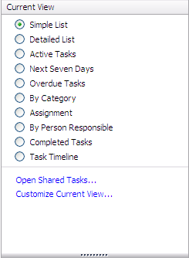
Microsoft Office Tasks Navigation Pane
Behavior
This navigation pane will be implemented as a simple radio button selection of available views. The list of available views may be more limited than what is shown in the graphic above (i.e., we wouldn’t likely support a Task Timeline). In addition, the scope of customization is likely to be cut for this version.

Tasks View
Description
The Tasks view will present a grid listing the tasks based on the selected view in the navigation pane. Columns will vary depending on the selected view, as well as the scope of the task list. In general, the following information will be available for any given task:
- Subject
- Assigned To
- Server
- Status
- Due Date
- % Complete
- Created By

Behavior
The grid view will support column sorting and grouping. Any task past its due date will be shown in red.
Filter options will be available for filtering based on task metadata. For example, the user could filter based on monitored server or group if necessary.
The following options will be available via context menu:
- Add Task – launches the Add Task dialog.
- Properties – launches the Task Properties dialog for the selected task. This option is only available if an existing task is selected. Double-clicking an existing task provides the same behavior.
- Mark Complete – sets the status of the selected task to Complete and the % Complete to 100%. This option is only available is an existing task is selected.
- Assign Task – launches the Task Properties dialog for the selected task and highlights the Assigned To field. This option is only available is an existing task is selected.
- Delete – deletes the selected task. This option is only available is an existing task is selected.

Not Supported
- Should we support reminder popups similar to Microsoft Outlook? If we don’t, we need to provide some other visual indicator, maybe on the SQLdm Today page regarding tasks with upcoming due dates.

Reports
TODO: This section is intended to simply lay the framework for how reports would be integrated into the desktop client. A more detailed specification is in development.

The Reports feature provides a number of default report templates and allows the user to create custom report templates that can be run over historical data collected and stored in the SQLdm Database.
It is important to note that this view is the primary historical reporting view. The real-time views, which make up the majority of the active desktop client views, will never show more than a day worth of historical data; this is a console configuration option.

Navigation Pane
When the Reports option on the navigation pane is selected, the navigation control will switch to a list of supported reports. These reports will be organized into categories, which may include the following:
- My Reports
  - This folder will contain custom report templates created by the user.
- Service Level Agreements
- Alerts
- Sessions
- Queries
- Resources
- Databases
  - General Statistics
  - Growth
- Services

Report View
When the Report feature is selected, it would likely be appropriate to show a “Getting Started” page that highlights specific reports as well as lists most recently run reports, including last run time. This page should also provide a link to the custom reporting option.
Once a report is selected in the Navigation Pane, the Report View will be driven by the Microsoft Report Viewer Control, which is based on the same concepts as Reporting Services. This view will provide filtering options based on the selected report. In some cases, other user interface components may provide more robust filtering in areas where the Report Viewer is lacking.

Custom Reports
The user can create a custom report template based on selected metrics stored in the SQLdm Database. Custom report templates are stored in the My Reports folder displated in the Navigation Pane.
Open Issues
- Should we provide a wizard for creating custom reports, or should we base it on a model similar to Salesforce reports?

Misc Dialogs

Connect to SQLdm Database
Refer to the Connect to SQLdm Database section.

Add Server
Description
The Add Server dialog can be launched from the main menu or server group context menu. The dialog will be similar to the “Connect to Server” dialog in Management Studio show below. The following options will be available on this dialog:
- Instance Name – name of the SQL Server instance to add.
- Browse – a button that launches a Browse for Server dialog that list servers available on the network.
- Windows or SQL Authentication – radio buttons to select authentication mode
  - Username – SQL username
  - Password – SQL password
- Add – commits the server add. This button is only enabled if all required field value have been specified.
- Cancel – cancels the server add.
- Help – launches the help topic associated with the dialog.
- Options – switches to the Server Properties dialog.

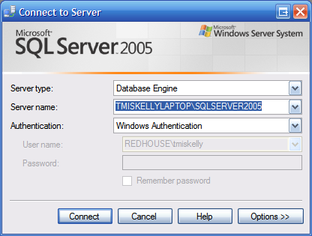
SQL Server Management Studio “Connect to Server” Dialog
Behavior
When the Browse button is selected, the Browse for Server dialog will make a call to the middle-tier to provide a list of available SQL Servers since it’s possible that the desktop client could be outside the DMZ.
The username and password fields are only enabled if SQL Server Authentication is selected; otherwise the credentials that the Collection Service is running as will be used to collect metrics.
The Options button will switch this dialog to Server Properties mode. All the same buttons described above will be available, just the content of the dialog will change.
If no server group is selected, the new monitored SQL Server will just be added to the default All Servers group.

Add Servers
Description
The Add Servers dialog allows multiple servers to be added as a single operation. This allows for quicker configuration of more than one server with varying connection properties.
This dialog will provide list of added servers, which will initially be empty. The following buttons will be provided to modify the list of server to add:
- Add – launches a dialog for adding new server and configuring basic server properties. This dialog would include the following options:
  - Server(s) - a text box for entering a comma-delimited list of servers to add.
  - Browse – a button that launches a Browse for Server dialog that list servers available on the network. Selected servers would be appended to the current list of servers.
  - Windows or SQL Authentication – radio buttons to select authentication mode
    - Username – SQL username
    - Password – SQL password
- Remove – removed the selected servers from the list of servers to add.
- Test – attempts to connect to each of the listed servers. An icon will be listed for each server with the following supported states:
  - Unknown – a connection had not been attempted
  - Success – a successful connection was established based on the configured connection properties
  - Failed – failed to establish a connection based on the configured connection properties

Server Properties
Description
This Server Properties dialog can be launched from the main menu or server context menu when a server is selected. The primary purpose of this dialog is to organize all server connection, collection and general configuration properties in a central location. The following form shows the basic layout.
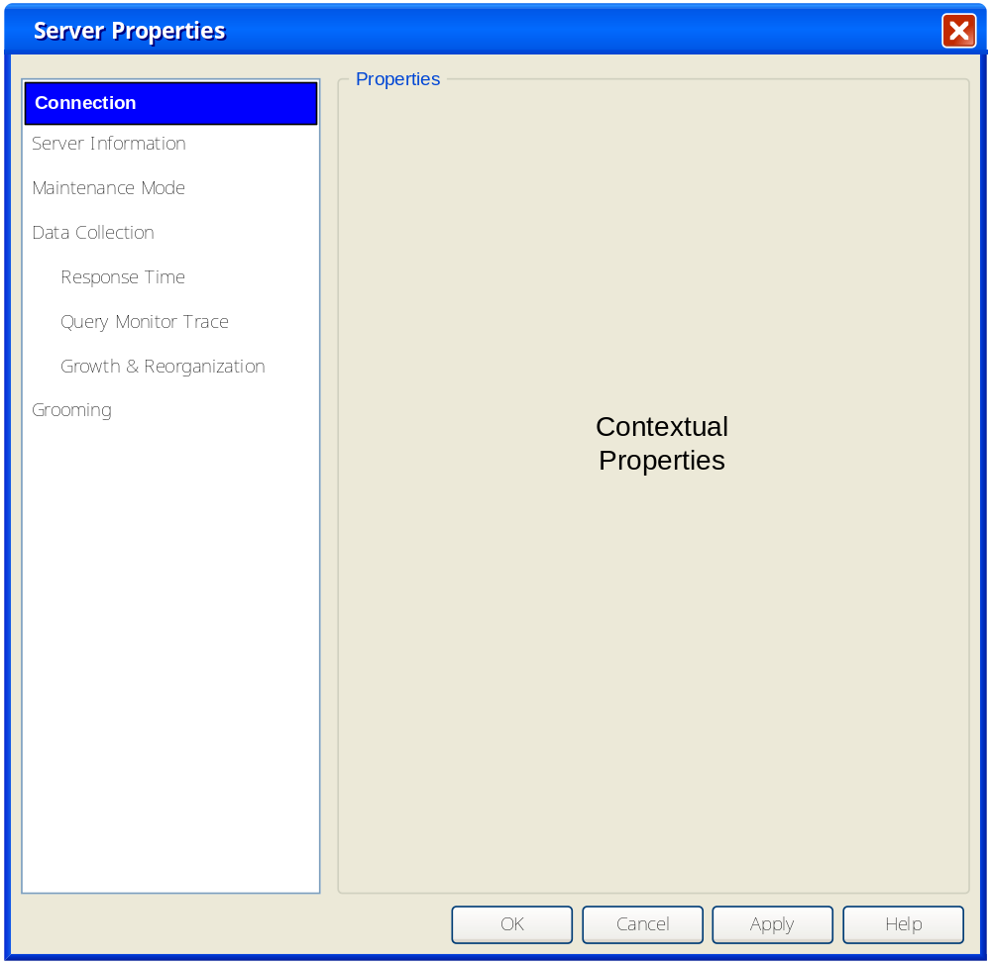
Server Properties Dialog

Properties are divided into sections, breaking down properties into logical chunks. The following properties will be available in each section:
- Connection
  - Instance Name – read-only SQL Serve instance name
  - Windows or SQL Authentication – radio buttons to select authentication mode
    - Username – SQL username
    - Password – SQL password
- Server Information – custom metadata regarding the monitored SQL Server
  - Department
  - Location
- Maintenance Mode
  - Enabled – checkbox to enable/disable maintenance mode
- Data Collection
  - Collection Interval – recurring collection interval in minutes
  - Connection Timeout – connection timeout in seconds
  - Command Timeout – command timeout in seconds
  - Enable Features
    - Query Monitor Trace
    - Growth & Reorganization
    - OS Metrics
- Response Time
  - SQL Statement – textbox that allows for a custom query that should be representative for collecting response time. “Select 1” is used by default. If the user enters a query that fails, response time will still be gathered around the failed query.
- Query Monitor Trace
  - Enabled – checkbox to enable/disable the query monitor trace
  - Trace Filters
    - Event to capture (checkboxes)
      - Stored Procedure and Trigger executions
      - Single SQL statement executions
      - SQL statement batch executions
    - Applications to exclude (checkboxes)
      - SQL Profiler
      - SQL Agent
      - SQL DMO
      - Like – textbox to enter “like” name
    - Performance filtering (all greater than filtering)
      - Duration – spinner based on number of seconds
      - CPU Usage – spinner based on number of seconds
      - Logical Reads – spinner based on number of logical reads
      - Physical Writes – spinner based on number of physical writes
- Growth & Reorganization
  - Enabled – checkbox to enable/disable growth and reorganization statistics collection
  - Collection Window – window of time within a given day within which to collection growth and reorganization statistics. If statistics cannot be gathered within the specified window of time, collection will be skipped until the following day.
  - Table Growth Statistics
    - Days to collect – series of checkboxes for each day of the week; if checked, statistics collection will be attempted during the specified collection window.
    - Exclude system tables – checkbox indicated whether system tables should be excluded from collection
    - Databases to exclude – list of all hosted databases with a checkbox indicated whether the database should be excluded from collection
  - Table Reorganization Statistics
    - Days to collect – series of checkboxes for each day of the week; if checked, statistics collection will be attempted during the specified collection window.
    - Exclude system tables – checkbox indicated whether system tables should be excluded from collection
    - Databases to exclude – list of all hosted databases with a checkbox indicated whether the database should be excluded from collection
- Grooming
  - Metrics
    - Number of days to retain collected metrics. Metrics older than the number of days specified will be deleted.
  - Alerts
    - Number of days to retain alerts. Alerts older than the number of days specified will be deleted.
Behavior
Property changes are applied immediately, meaning that a new collection is forced at the time of the changes. This behavior allows for changes such as enabling/disabling the Query Monitor Trace to be enforced as soon as possible after a change.
Collection windows are based on the monitored SQL Server time.
Grooming will likely be enforced by a SQL Server Agent job, so these changes will be picked up the next time the job is scheduled to run.
Notes
- We need to consider support for maintenance mode.
- Archiving should be supported via the configuration options or a KB should be provided for manual configuration.
- Should grooming be more granular? For example, we currently support grooming of trace data separately; should we continue to support that now that we have a central repository? Probably a KB.

Add Server Group
Description
When the Add Server option is first selected, a Yes/No/Cancel dialog will popup asking the user whether the group should be based on a search filter, such as the Critical and Warning groups. If the answer is yes, the following dialog options will be presented (based on a similar layout to the Server Properties dialog):
- General
  - Group Name – the name of the server group
  - Description – textbox for including a brief description of the group
  - Hide – checkbox indicating whether the group is hidden
- Filter
  - This property area will contain similar functionality to Microsoft Outlook’s Search Folder Criteria dialog shown below. The basic idea is that metric or server state values criteria can be specified. A logical AND of each specified condition is performed after each refresh to determine which servers are included in the group.

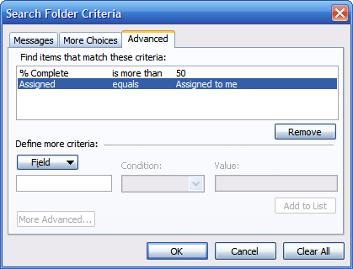
Microsoft Outlook’s Search Folder Criteria Dialog

If the answer is no, the following static group properties will be presented (based on a similar layout to the Server Properties dialog):
- General
  - Group Name – the name of the server group
  - Description – textbox for including a brief description of the group
  - Hide – checkbox indicating whether the group is hidden
- Servers
  - Available Servers – a list of monitored servers not currently included in the group.
  - Server Included – a list of monitored servers included in the server group.
  - Add/Remove/Add All/Remove All – buttons between to two list boxes for adding/removing monitored servers from the group.

Server Group Properties
Description
The Server Group Properties dialog will offer the same options as the Add Server Group dialog. The only difference between the two dialogs will be the inclusion of OK/Apply buttons rather than an Add button.
Behavior
For static server groups, if a server that was included is no longer monitored, it will no longer show up in the Servers Included list.
For search filter groups, an automatic refresh of the group will be performed when changes are applied.

Metric Properties
Description
The Metrics Properties dialog will allow for modifying metric thresholds. The design of this dialog will compete with that of Quest Spotlight (shown below). This dialog must support OK, Warning and Critical threshold value ranges as well as Boolean thresholds such as service status.

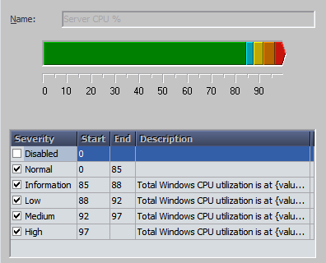
Quest Spotlight Metric Threshold Properties
Behavior
At this point, only OK, Warning and Critical thresholds must be supported. The ranges of these values vary depending on the metric; refer to the Event and Notification specification for a complete list of supported metrics. Each threshold range can be enabled or disabled and the entire metric event can be disabled as well.
In some cases, such as service status, only Boolean values will be supported. For example, a value of 0 would indicate that the service is stopped, which would raise a Critical event.
Value ranges can be set explicitly or can be set using a convenient range slider as represented in the graphic above. The minimum and maximum values for the range slider will vary depending on the metric.
Once new metrics thresholds are applied, the desktop client control that support visual cues will immediately take the new values into account, while events raised for these thresholds will take effect on the next scheduled collection.
In the future, adding custom thresholds should be considered.
Notes
- At this point, we only support thresholds on a limited set of metrics. There really is no good reason for this. We should consider supporting more of the metrics we collect so there’s more flexibility for presentation options in the desktop client. There are some cases in the existing desktop client where visual cues are provided (read: hard-coded) for metrics where thresholds values cannot be changed. There really is no good reason for that.

Console Options
Description
The Console Options dialog will provide general options for desktop client operation and presentation. This dialog will have a similar look-and-feel to the Server Properties dialog. The following options will be available:
- General
  - File Location – allows the user to specify alternative locations for configuration and cache files.
- Data Collection
  - Refresh Rate – the rate at which the data shown in the active view is refreshed. This value is specified in number of seconds, with a minimum of one second and a maximum of 999. A warning would be presented if the refresh rate is set below ten seconds.
  - History – limits the amount of history stored for metrics collected on-demand (outside of the scheduled collection interval). This value can range from five minutes to one day.
- Startup – allows the user to specify which view should be shown as the startup screen. The following options are supported:
  - Getting Started
  - SQLdm Today
  - Current View
- Notifications – we will support task tray notification similar to our current desktop client. The following options will be supported:
  - Show SQLdm in task tray – allows for enable/disable of task tray status icon. All other options are only available if this option is enabled.
  - Show alerts for (all enable/disable checkboxes) – shows alert notification popups for the following:
    - State changes only
    - Critical
    - Warning
    - Clear (revert to OK)
  - Do not show alerts if SQLdm Desktop Client is active – disables alert notification popups if the desktop client is the active window
- Appearance
  - This is where we would provide options for customizing the appearance of the desktop client. For example, we may provide options for customizing general graph appearance. We’ll update this option as we determine what type of options would be useful.
- Help
  - This is where we would provide help customization options. For example, we may choose to provide popup help similar to Quest Spotlight on metric bound controls when threshold violations occur. However, some users might find that annoying over time and decide to disable it. That type of option would be provided here.
Behavior
Once applied, all options changed in this dialog will be applied immediately. In this case that the History option for Data Collection is changed, all data in excess of the specified time frame will be disposed.
Notes
- A background refresh rate will likely be supported. This would include Alerts and Tasks items that may be outside the context of the active view. The details of this configuration option will be provided at a later time.

Add Notification Rule
Description
The Add Notification Rule dialog will be the same as the Notification Rule Properties dialog, except that it will have an Add button rather than an OK button.

Notification Rule Properties
Description
The Notification Rule Properties dialog (shown below) will allow for constructing notification rules based on custom conditions and notification destinations. A notification rule can have a combination of conditions that must be matched before a notification will be sent. As the rule is modified, an easy-to-read description of the rule will be dynamically constructed in a rich-textbox where custom properties of conditions and notification destinations can be modified.
Behavior
Any combination of the following conditions can be specified, with the noted criteria customizations:
- Where the SQL Server instance name is…
  - A combination of monitored SQL Server instance names can be specified that will be evaluated with a logical OR operation.
- Where metric severity is…
  - A combination of metric names can be specified that can be evaluated with a logical OR or AND operation.
  - Evaluation criteria can be customized, including the following operations:
    - less than
    - less than or equal to
    - greater than
    - greater than or equal to
    - equal to
    - not equal to
  - Severity can be set to:
    - OK
    - Warning
    - Critical
- Where metric value is…
  - A combination of metric names can be specified that can be evaluated with a logical OR or AND operation.
  - Evaluation criteria can be customized, including the following operations:
    - less than
    - less than or equal to
    - greater than
    - greater than or equal to
    - equal to
    - not equal to
    - in the range
    - outside the range
  - Values can be set to any string value. It’s in the hands of the user to understand the value type and unit of measure for a specified metric.
- Where time collected is…
  - Day of week
    - Sunday – Saturday checkboxes
  - Time range
    - Start time
    - End time

At least one notification destination must be specified to be considered a valid rule. The list of notification destinations will be based on the configured notification providers. Refer to the Configure Notification Providers dialog for more information about available notification providers and destination customization.
Configured notification rules are processed each time a new snapshot is collected.
Notes
- Should we allow for logical OR operations? This will likely be valid for additional metric condition metadata such as enumerated status values like Database Status, where the values are outside of a Boolean range.
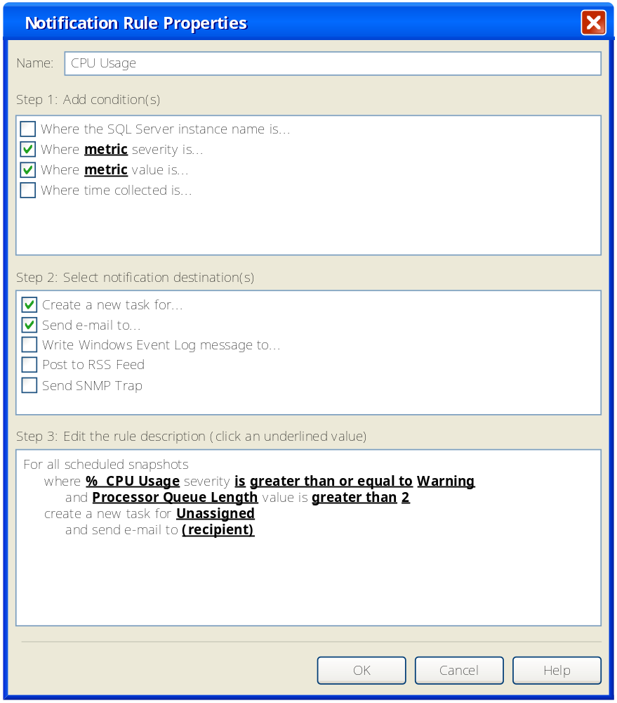
Notification Rule Properties Dialog

Configure Notification Providers
Description
The Configure Notification Providers dialog lists configured notification provider instances. In this version, the list of provider instances will be limited to the following:
- SMTP
- Windows Event Log
- ODBC
Users will not be provided an option to add new provider instances or delete existing ones; the only options available will be to edit the properties of the default instances or disable an instance.
Behavior
To edit the properties of a provider instance, the user can double-click on the instance or select an instance and click the Properties button. A properties dialog will be presented tailored to the selected provider instance. For example, in the case of the SMTP provider, the following properties would be available:
- Server
- Port Number
- Authentication Required – checkbox indicating whether authentication is required to send messages on the specified SMTP server. If selected, the following properties must be provided:
  - Username
  - Password
- From Name
- From Email Address
- Timeout – the number of seconds to wait before timing out.

For details about the configurable properties of each supported provider, refer to the Event & Notifications specification.
Destination properties (i.e. recipient email addresses) of supported providers will be configured via the Notification Rule Properties dialog. Not all providers will support custom destination properties. For example, the file location for the RSS Feed provider will be configured as a provider property; no destination properties will be available.
The effect of disabling a provider instance will be that no notifications will be sent via that provider for notification rules that have been configured to use that instance. For example, if the SMTP provider were disabled, no notification emails would be sent for any rule specified to use it; that provider would simply be skipped that notification rule until the provider is re-enabled.

Add Task
The Add Task dialog has the same behavior as the Task Properties dialog, except instead of an OK button for saving changes, an Add button will be presented.

Task Properties
Description
The Task Properties dialog provides options for changing the properties of a given task. These properties include:
- Subject – a short description of the task
- Assigned To – this will likely be based on domain/username
- Due Date – calendar dropdown for selecting due date. Setting this value to a date in the past will result in the task being displayed in red in the Tasks view.
- Status
  - Not Started
  - In Progress
  - Completed
  - Waiting on someone else
  - Deferred
- % Complete – 0 thru 100% complete
- Description
- Private – a checkbox indicating whether the task is private, meaning the user that created it is the only one that can see it. This option is only available if the current user is the user that created the task.

OK and Cancel buttons will be provided for committing changes or backing out of them. A Help button will also be provided for this dialog to show context sensitive help.
Behavior
Any changes made to tasks will be immediately committed to the SQLdm Server, meaning new task assignments should show up the next time the Tasks view is refreshed for a user.
Notes
- Recurring tasks will not be supported in this version.
- The Assigned To field will be a simple text field for filtering.

About Idera SQLdm
Description
This dialog will include the following information and options:
- A pretty picture of the SQLdm Logo.
- Copyright
- Support contact info
- Version Information
  - Desktop Client Version
  - Management Service Version
  - Collection Service Version
  - Metrics Repository SQL Server Version
- Active License

Manage Licenses
Description
The Manage Licenses dialog will have the same look-and-feel as our other new product license dialogs. The license dialog for SQLsecure is shown below:

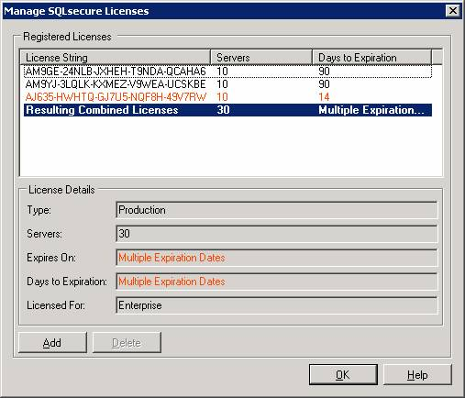
SQLsecure Manage License Dialog
Behavior
This Manage Licenses dialog behavior will be based on the “Guide to License Requirements” document posted on the Idera intranet site.

System Diagnostics
Description
The purpose of the System Diagnostics dialog is to provide diagnostic information regarding the operation of the SQLdm Server components. The type of information provided in this dialog would include:
- SQLdm Database availability & response time
- SQLdm Management Service availability & response time
- SQLdm Collection Service availability & response time

Help Integration
At the very least, F1 help integration for each view, as well as main menu support will be available. Some other ideas for help integration have been provided in this specification, but the viability of those suggestions is yet to be determined.
TODO: Discuss help integration issues with Marlowe. This information may be included in a separate specification.

Installation and Upgrade
Refer to the SQLdm Installation Specification for installation design and implementation details.

Permissions and other Required Configuration

Licensing Issues
Licensing will be enforced by the Management Service. Please refer to the “Guide to License Requirements” document published in the Idera intranet site.

Dependencies

Dependencies on Idera Software

Third-Party Software Required on the Customer Machine

Third-Party Software Required Internally

Technical Design

Architecture
An overview of the architecture behind this feature – how it works, components, communication between components etc

Installation Issues
Refer to the SQLdm Installation Specification for installation design and implementation details.

Schedule

Work Breakdown and Sizings
Insert areas that put the implementation or schedule at risk – Assumptions made in design, new areas that have a learning curve etc. Break the project into logical components and add time for design, coding, integration, unit testing. These estimates should not take into account outside forces like maintenance work. These will be applied in building the overall project schedule. A general rule of thumb is to break any unit of work greater then 1 week into smaller pieces to ensure accuracy and to allow measurement of progress during the project.
Component | Who | Sizing
R&D
Code Piece #1
Code Piece #2
Porting
Unit and Integration Testing
Total

Areas of Risk
There are many types of risks. For example, a section might describe
- Areas with big learning curve
- Design assumptions that still need to be proven
- a technical hurdle that needs to be overcome.
- An area which has many unknowns
- Outcomes of other plans/implementations which could affect the deliverability of this feature.
Where possible, each section should explain the risk, quantify the risk, enumerate possible actions to address the risk, and recommend the action that is appropriate.

Quality Assurance Considerations

Overview
Insert explanations for QA considerations that are not apparent from the rest of the specification. Include things like tests on platforms that you want run in greater width then a developer can easily do or which tests you would want as an acceptance test each time a release goes out the door.
This section should identify all the testing activity that should be performed to verify the project has:
- Satisfied the completion criteria
- Works consistently with the existing components or works at least as well as the component being replaced
- No other components have lost functionality or no longer work
- Meets the standards as defined and approved by this document
- Identifies all the edit rules for each data element in the process

Documentation Considerations

Bibliography
- Troubleshooting Performance Problems in SQL Server 2005
http://www.microsoft.com/technet/prodtechnol/sql/2005/tsprfprb.mspx

